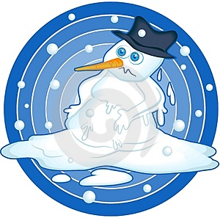
Physical Science Unit 3 – Physical Changes

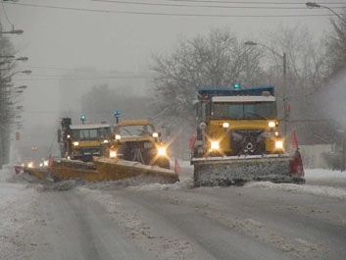
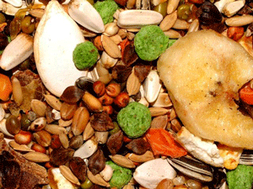


Unit 3 Overall Objective:
Students will understand and apply knowledge of the structure and properties of matter.

After completing this unit, you should be able to understand and explain the following:
- Molecules change speed during phase changes and produce a new state of matter.
- Matter can be classified into three major groups
- Physical and chemical changes differ in their products and means of use.
- Changes in matter result in energy changes. Where does that energy go and how can it be reduced?

Textbook reference:
Chapter 2, Section 3 (p.50-55)
Chapter 3, Section 1 and 2 (p.70-81)

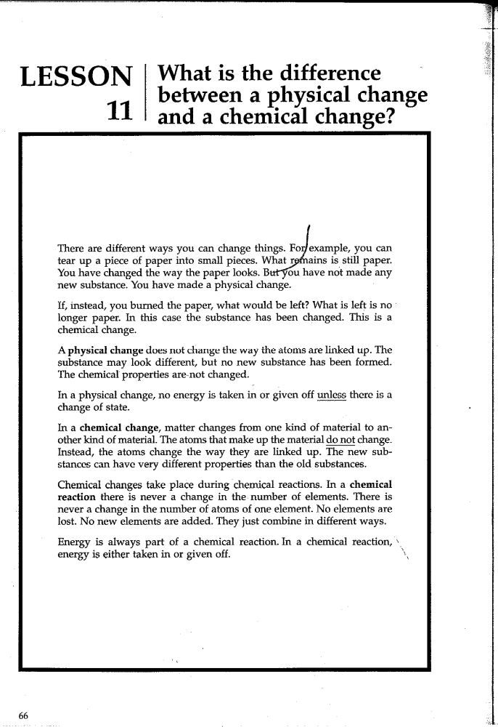
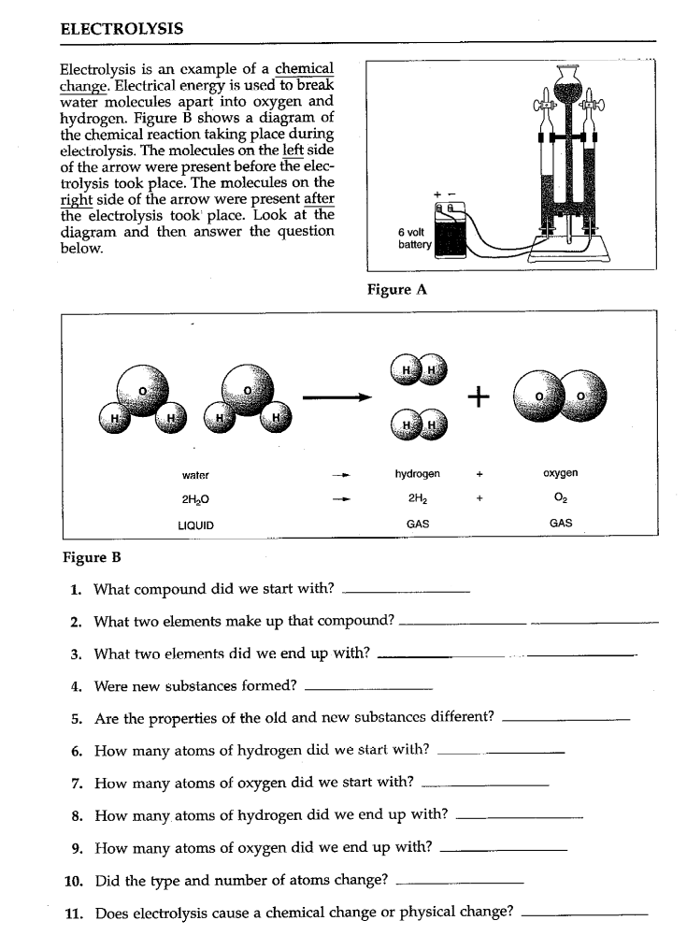
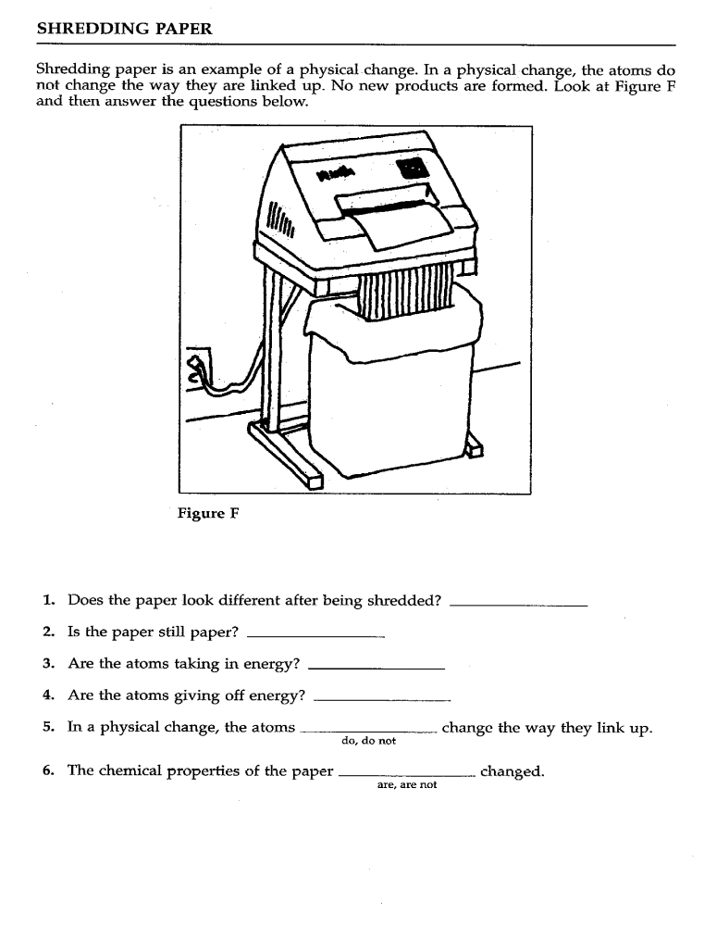
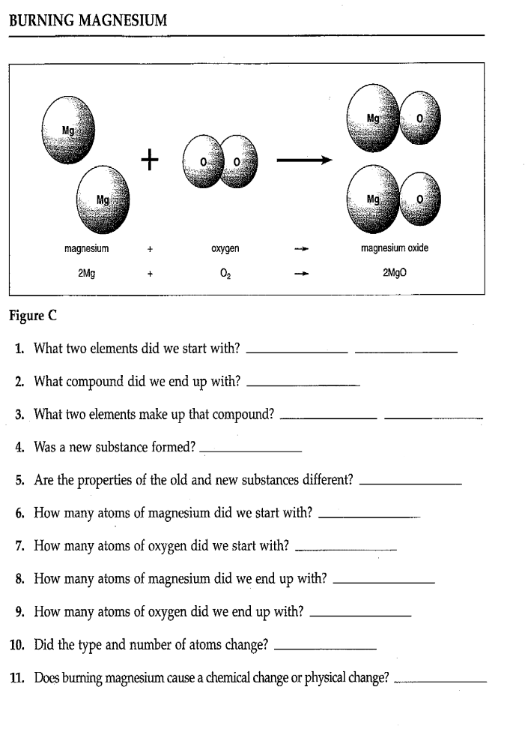

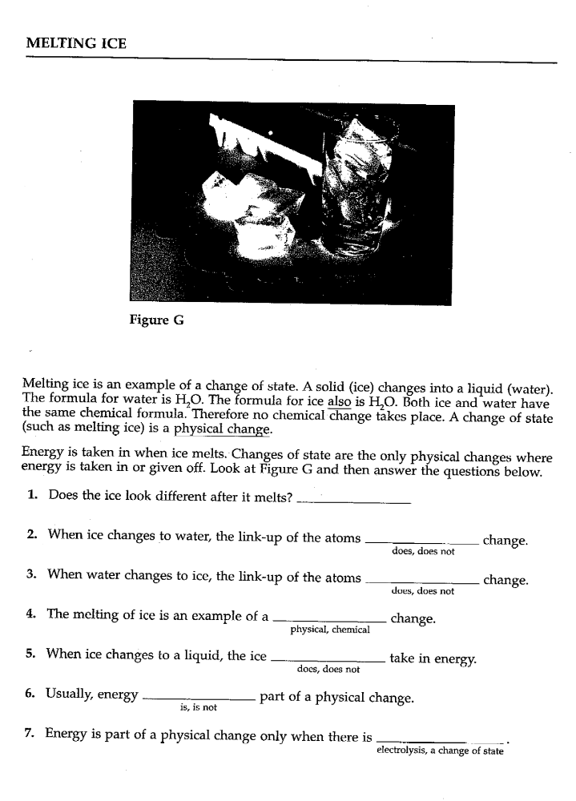
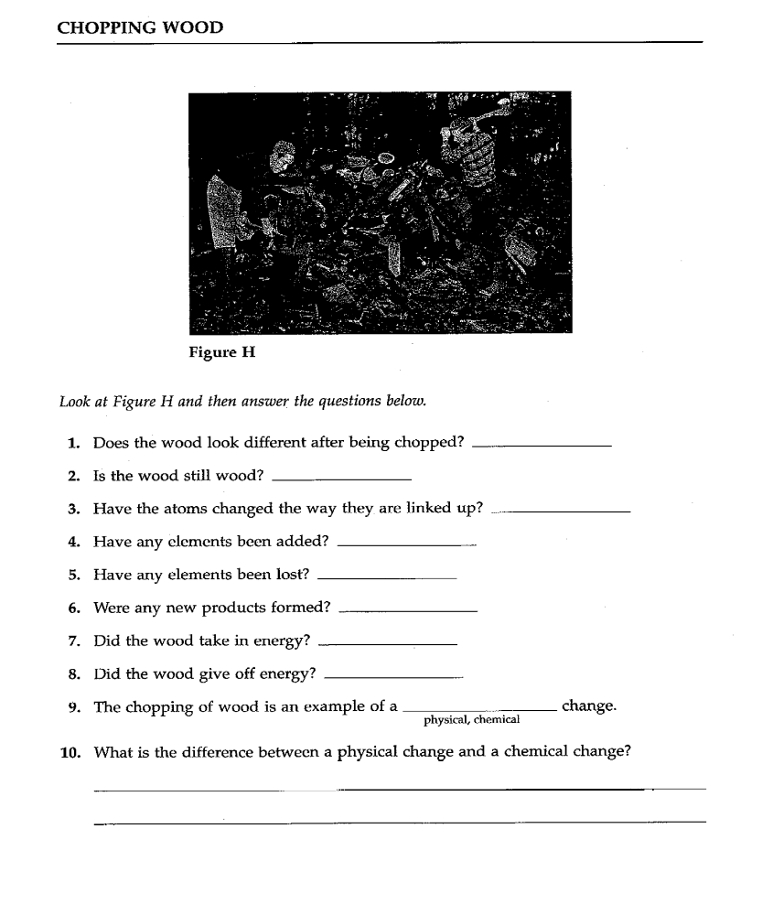

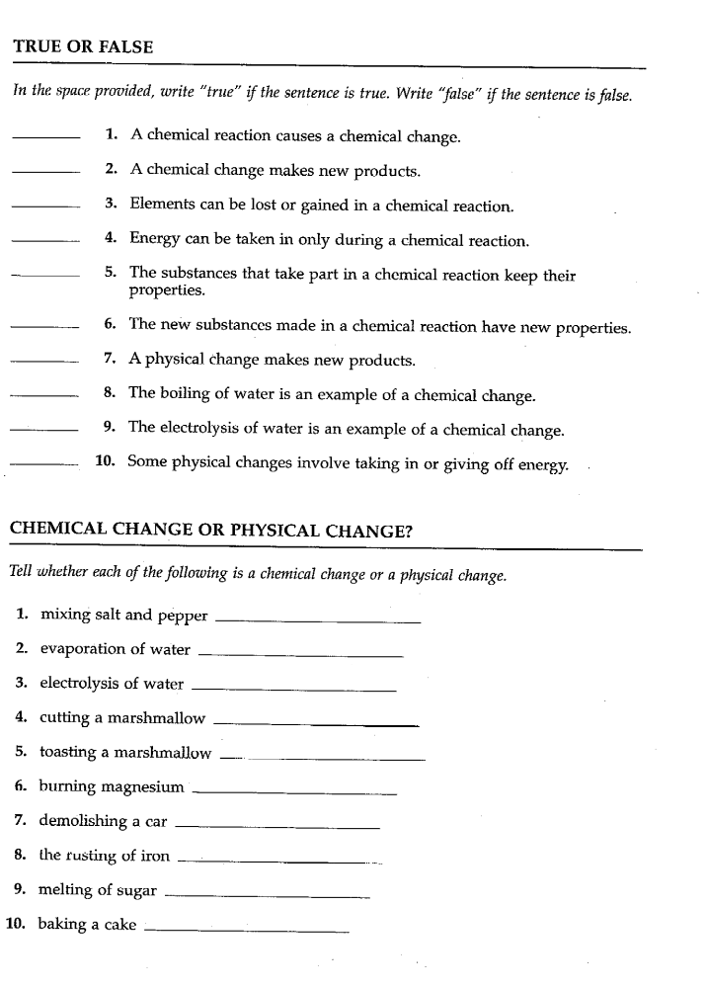
H₂O Phase Changes and the Impact of a Solute

Background:
1. Kinetic Energy = the energy of motion
2. Potential Energy = stored energy
3. Solvent = does the dissolving; what a substance is dissolved in (water for example)
4. Solute = gets dissolved by the solvent; substance that is dissolved (salt for example)

Materials
Hot Plate Beaker Ringstand
Thermometer Ice Test Tube Clamp
Stop Watch Stirring Rod

How to take the temperature for ALL parts:
1. NEVER stir the solution with the thermometer. It costs $10 more than a glass stirring rod and will ruin your data if it breaks.
2. ALWAYS use a glass stirring rod to stir.
3. Stir the solution before taking your temperature.
4. Do not let the glass bulb of your thermometer touch the bottom of your beaker.
5. Do not let the glass bulb of your thermometer come out of the water or icewater.

Part 1:
1. Fill a 400mL beaker one-half to three-quarters full with ice.
2. Record the temperature every 30 seconds for 5 minutes. Record your temperature in your data table. REMEMBER: stir before taking the temperature.
3. While keeping your time running, after 5 minutes, place the beaker on a hot plate.
4. Set the hot plate between medium and high (between 250-300).
5. Continue to record the temperature every 30 seconds. Your water should come to a full boil.
6. Stop recording your temperature after 30 minutes.

Phase changes of Water
Notes | Time in minutes | Temperature in ºC | Time in minutes | Temperature in ºC
No Hotplate | 0.0 |  | 8.5
 | 0.5 |  | 9.0
 | 1.0 |  | 9.5
 | 1.5 |  | 10.0
 | 2.0 |  | 10.5
 | 2.5 |  | 11 | IMPORTANT  1) Record time all ice is gone  2) Stir until all ice is gone  3) Stop recording temps after 30 minutes
 | 3.0 |  | 11.5
 | 3.5 |  | 12
 | 4.0 |  | 12.5
 | 4.5 |  | 13
Hotplate | 5.0 |  | 13.5
 | 5.5 |  | 14
 | 6.0 |  | 14.5
 | 6.5 |  | 15
 | 7.0 |  | 15.5
 | 7.5 |  | 16
 | 8.0 |  | 16.5
 | 17 |  | 23.5
 | 17.5 |  | 24
 | 18 |  | 24.5 | IMPORTANT  1) Record when water starts to boil  2) Stop recording temps after 30 minutes
 | 18.5 |  | 25
 | 19 |  | 25.5
 | 19.5 |  | 26
 | 20 |  | 26.5
 | 20.5 |  | 27
 | 21 |  | 27.5
 | 21.5 |  | 28
 | 22 |  | 28.5
 | 22.5 |  | 29
 | 23 |  | 29.5
 |  |  | 30

Part 2:
1. Fill a 250mL beaker with 100mL of distilled water.
2. Bring the water to a boil. Take the temperature of the water and record the temperature in your data table.
3. Remove the thermometer from the water. Wait 1-2 minutes and take and record the temperature of your boiling water again. Make sure that the temperature on your thermometer has dropped closer to room temperature before you place it back into the water.
4. Wait another 1-2 minutes with the thermometer out of the beaker. Again, take and record the temperature.
5. Add 15g of salt to you beaker of water. Bring the water to a boil again, making sure to stir the salt so that it is completely dissolved.
6. Repeat steps 2-4 with the salt water.

Boiling Point of Water with and without solute (NaCl/table salt)
Solution | Temp 1 (ºC) | Temp 2 (ºC) | Temp 3 (ºC)
No Salt
15g Salt

Part 3:
1. Fill a 250mL beaker with 100mL of ice.
2. Add 25mL of water.
3. Stir the solution for 2 minutes with a stirring rod.
4. Record the temperature for the ice water and record the data in your data table.
5. Remove the thermometer from the ice water. Wait 1-2 minutes and take and record the temperature of the ice water again. Make sure that the temperature on your thermometer has dropped closer to room temperature before you place it back into the ice water.
6. Wait another 1-2 minute with the thermometer out of the beaker. Again, take and record the temperature.
7. Empty the beaker and again fill it with 100mL of ice and 25mL of water. Now add 15g of salt.
8. Repeat steps 3-6 and record your data.

Melting Point of Water with and Without Solute (NaCl/table salt)
Solution | Temp 1 (ºC) | Temp 2 (ºC) | Temp 3 (ºC)
No Salt
15 g Salt

Questions

1. Make a graph for your data from Part 1 on the next page or using a computer.
-label all phases and phase changes
-with your pen or pencil, add a line for gas (steam)

2. Using your graph you drew in question 1, when did the temperature start to rise rapidly? (Hint: it probably did not happen at the seven minute point).

100 ºC
0 ^{O}C

5. Indicate (on the graph above) where kinetic energy/temperature is increasing.

6. What does salt do to the evaporation/condensation point of water? Use a red pen to draw in the new line.

7. What does salt do to the melting/freezing point of water? Use a blue pen to draw in the new line.

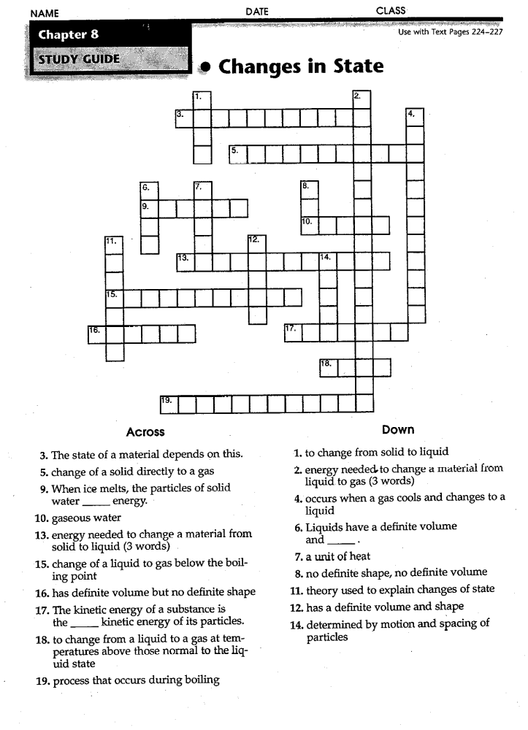
Prentice Hall: Physical Science
Chapter 3 Section 2 (p.76-81) – Phase Change
Also, you can use the diagram on p.488-489 for additional help with #1

Fill in the chart below using the terms freezing, vaporization, condensation, and liquid.
Solid
_____________
Gas
Plasma
Ionization
Melting
__________________
______________

______________

What happens to the particles of a gas during condensation?

a. Do they get faster or slower?

b. Do they get closer or farther apart?

- What happens to the particles of a solid during melting?

a. Do they get faster or slower?

b. Do they get closer or farther apart?

- When a substance goes through sublimation, what state of matter is “skipped over”?

- What phase change is used to describe how clouds are formed?

- Use the graph on the top of page 80 to answer the following questions:
  - What are the two variables that are plotted on the graph?

  - What is happening to the temperature of the water on the part of the line labeled as ‘C’?

  - What is happening to the temperature of the water on the part of the line labeled as ‘B’?

  - What does the temperature of line ‘B’ represent?

  - What does the temperature of line ‘D’ represent?
Prentice Hall: Physical Science
Chapter 2 Section 1 (p.34-42)

- What is an element?

- What is a compound?

- Classify the following substances as an element or a compound.
calcium carbon
carbon dioxide chalk

mercury oxygen
chlorine copper
graphite hydrogen
water sugar
zinc salt
sodium
Element | Compound

- What is a mixture?

- What are the two types of mixtures?

- Fill out 3 facts and 1 example about each of the following:
Heterogeneous Mixtures | Fact #1
Heterogeneous Mixtures | Fact #2
Heterogeneous Mixtures | Fact #3
Heterogeneous Mixtures | Example

Homogeneous Mixtures | Fact #1
Homogeneous Mixtures | Fact #2
Homogeneous Mixtures | Fact #3
Homogeneous Mixtures | Example

- What are the 4 ways that your book says we can separate a mixture? Give a brief explanation of what they are doing in each of the pictures.

Compounds and Mixtures at Home

Directions: Locate and identify three compounds, three heterogeneous mixtures and three homogeneous mixtures. Be sure to explain a reason for your choice and how you would separate the heterogeneous mixtures.

Purpose: ________________________________________________________________

________________________________________________________________

________________________________________________________________.

C=Compound,
Homo=homogeneous mixture, Hetero=heterogeneous mixture
Number | Item | E, C, Homo, Hetero | Reason for Choice | How Would I Separate Them?
1.

2.

3.

4.

5.

6.

7.

8.

9.

Questions:

- Using your choices for heterogeneous mixtures, define heterogeneous mixture in your own words.
______________________________________________________________________________

- Using your choices for homogeneous mixtures, define homogeneous mixture in your own words.
______________________________________________________________________________

- Classify steel and explain your reason (you may have to look this one up)

________________________________________________________________

________________________________________________________________

Name: _____________________________

Filter This Mess Lab

Purpose:

Here we go…another ice storm! This time your dad doesn’t want you to take any chances, so he tells you to go salt the driveway. You discover that your little brother was having some fun at your expense. He mixed all of your salt with the sand from his sand box. What a mess! You know that your dad won’t spend more money on new salt, so you have to figure out some way to separate it all. That’s where Science comes in!

Materials:

Hot plate Iron Ring
Safety Goggles Filter Paper
Stirring Rod Beakers
Funnel Graduated Cylinders
Ring Stand Crucible
Evaporating Dish Tongs

Pre-Lab/New Vocabulary:

- Define Residue:

- What are two physical properties of sand?

- What are two physical properties of salt?

- What happens when you add sand to water?

- What happens when you add salt to water?

**YOU MUST WEAR GOGGLES DURING THIS ENTIRE LAB!!**

Procedure:

- Obtain 2-3 scoopfuls of a mixture of salt and sand.

- Determine the mass of this mixture and record it in your data table.

- Set up the filter apparatus the same as on the teacher’s desk. Fold the filter paper as demonstrated. Find the mass of the filter paper and record it.

- Place the filter paper in the funnel and wet it so that it sticks to the walls of the funnel. Make sure the beaker under the funnel is clean and dry.

- Dissolve the salt and sand solution with about 15 mL of water.

- Slowly pour the mixture through the funnel making sure not to overflow the filter paper.
- Place the filter paper with the residue (RESIDUE A) on a hotplate set at 1.

- Find the mass of an evaporating dish and record it in the data table.

- Place the evaporating dish on the hot plate making sure the hot plate is set no higher than 6.

- Pour some of the contents of the beaker into the evaporating dish and heat it carefully. The liquid has a tendency to splatter if it is heated too quickly. If this happens remove the evaporating dish with tongs and lower the setting on the hot plate and perform again.

- Continue to slowly add the contents of the beaker to the evaporating dish until almost all the liquid has been evaporated.

- Remove the evaporating dish from the hot plate. The remainder of the liquid should evaporate because the dish is still very hot.

- When the evaporating dish has cooled, find the mass of the evaporating dish with its residue (RESIDUE B) still in it. Record the mass of residue B.

- When the filter paper and residue A are dry, find the mass of both and record it.

Data Table:

MASSES | Lab Data | Calculated Data
A. Mixture |  | D. Residue-A  (Data C - Data B)
B. Filter Paper |  | D. Residue-A  (Data C - Data B)
C. Filter paper with Residue-A |  | D. Residue-A  (Data C - Data B)
E. Evaporating Dish |  | G. Residue-B  (Data F - Data E)
F. Evaporating Dish with Residue-B |  | G. Residue-B  (Data F - Data E)
H. Mass of mixture after separation

(Residue-A + Residue B)

% difference

Mass of Mixture (Data A) - Mass of Mixture After Separation (Data H)
------------------------------------------------------------------------------------------- X 100
Mass of Mixture (Data A)

Questions:

- Is the mixture in the beginning of the lab heterogeneous or homogeneous? Explain your answer.

- After filtering, what was left in the paper funnel?

- After filtering, what was in the beaker under the funnel?

- What is RESIDUE A?
- What is RESIDUE B?

- Is your percentage from the Calculations area large? Why or why not?

- Could a mixture of salt and sugar be separated the same way? Why or why not?

- Could water and gasoline be separated the same way? If not, what properties could be used to separate them?

Information: Elements, Compounds, Mixtures

Examine the following tables. Following the name of each element or compound is the “chemical formula” of the element or compound; please see the periodic table for the meaning of some of the symbols (i.e. Na = sodium).

Elements | Compounds
Sodium (Na) | Water (H₂O)
Chlorine (Cl) | Methane (CH₄)
Carbon (C) | Sodium chloride, salt (NaCl)
Oxygen (O) | Carbon dioxide (CO₂)
Hydrogen (H) | Hydrogen Peroxide (H₂O₂)

Pure Substances | Mixtures
Salt (NaCl) | Salt water (NaCl and H₂O)
Hydrogen (H) | Sand
Carbon dioxide (CO₂) | Hydrogen (H) and Oxygen (O)
Water (H₂O) | Sodium (Na) and Chlorine (Cl)
Aluminum (Al) | Kool-aid (sugar, water, etc.)

Critical Thinking Questions

- How are elements different from compounds?

- How are compounds different from mixtures?

- How are pure substances different from mixtures?

- Can something be both a mixture and a pure substance? Explain using examples from the tables.

- Is it always possible to identify something as an element, compound, pure substance or mixture just by looking at it? Explain using examples from the tables.

- Formulate a definition for each of the following terms.
- element:

- compound:

- mixture:

- pure substance:

- Categorize each of the following as an element, compound, mixture, or pure substance. If more than one label applies, then include both labels. (You will need more than one label sometimes.)

a) ___________________ Popsicle c) _____________________ Gold

b) ___________________ Sugar d) _____________________ Dishwater

- If you have a container with hydrogen gas and oxygen gas in it do you have water? Why or why not?

- Give an example of something that is an element. Your example should not already be on this sheet.

- Give an example of something that is a compound. Your example should not already be on this sheet.

- Give an example of something that is a mixture. Your example should not already be on this sheet.

INQUIRY: Homogeneous and Heterogeneous Mixtures

Examine the following table.

Example of Mixture | # of things in mixture | How many kinds of states in mixture | Homogeneous or heterogeneous?
Salt water | 1 | 2 | Homogeneous
Oil and water | 2 | 1 | Heterogeneous
Sugar and salt (no water) | 2 | 1 | Heterogeneous
Sugar and salt in water | 1 | 2 | Homogeneous
Sand and water | 2 | 2 | Heterogeneous
Carbon dioxide, water, and ice | 3 | 3 | Heterogeneous
14 kt. gold (mixture of silver and gold) | 1 | 1 | Homogeneous

Critical Thinking Questions

- What relationship exists between a homogeneous mixture and the number of things in the mixture?

- What is the difference between homogeneous and heterogeneous mixtures?

- If you had to categorize elements as homogeneous or heterogeneous, what category would you put them in?

- If you had to categorize compounds as homogeneous or heterogeneous, what category would you put them in?

- Categorize each of the following as homogeneous or heterogeneous.

___________ a) salad ______________ b) ice water

___________ c) dishwater ________________ d) 14 kt. Gold
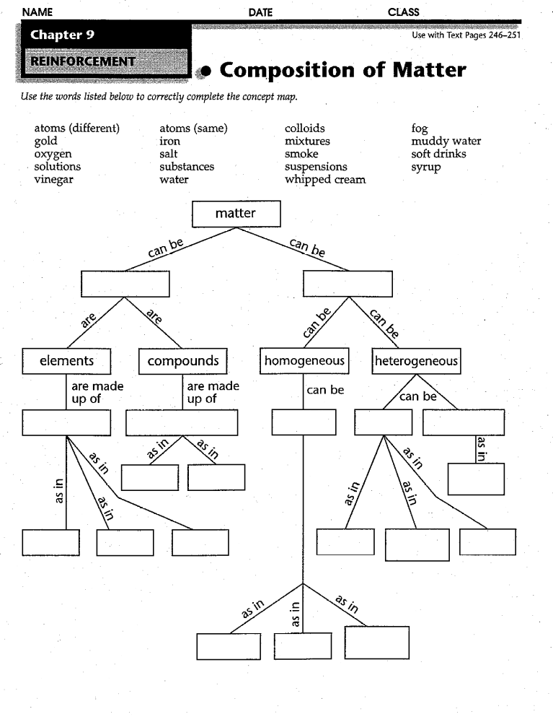
Go to http://www.harcourtschool.com/activity/mixture/mixture.html
**This activity only works on Internet Explorer!!**
After the activity, fill in the table below with what you discovered.
 | Mixture | Separation Mechanism | Physical Properties that allow separation
Sand and Iron Filings
Salad
Salt and Water
Muddy Water
Dust in Air

Go to http://www.quia.com/rr/33049.html

Play the rags to riches game. Describe what each object is and why.
Object | Type | Why is that the correct answer?

Read the section & take the quiz. Record a summary of the correct answers below.
1.____________________________________________________________________________
2..___________________________________________________________________________
3..___________________________________________________________________________
4..___________________________________________________________________________
5..___________________________________________________________________________
6..___________________________________________________________________________
7..___________________________________________________________________________
8..___________________________________________________________________________
9..___________________________________________________________________________
10.__________________________________________________________________________
Reading Link: http://chem4kids.com/files/matter_mixture.html
Quiz Link: http://chem4kids.com/extras/quiz_mattermix/index.html

Read the section and take the quiz. Record a summary of the correct answers below.
1.____________________________________________________________________________
2. ___________________________________________________________________________
3. ___________________________________________________________________________
4. ___________________________________________________________________________
5. ___________________________________________________________________________
6. ___________________________________________________________________________
7. ___________________________________________________________________________
8. ___________________________________________________________________________
9.____________________________________________________________________________
10.__________________________________________________________________________
Reading Link: http://chem4kids.com/files/matter_solution.html

Quiz Link: http://chem4kids.com/extras/quiz_mattersolution/index.html

