Name:_______________________
-Seismic Waves Exploration-
Procedure
- Go to http://aspire.cosmic-ray.org/Labs/SeismicWaves/ (Note: You MUST use Internet Explorer!!)

- Spend 1-2 minutes playing with the Mighty Wave Maker and answer the questions online.
- Using the paragraph below the first set of multiple-choice questions, list 2 facts about P-waves:

- Using the paragraph below the second set of multiple-choice questions, list 2 facts about S-waves:

- Click on “Discover More About Earth’s Interior”. Follow the instructions on the website as you move through the next three slides. When you get to the fourth slide, label the layers of the Earth below:

- Still on slide four, click on one of the houses. On your diagram, draw where the P and S waves travel (make sure to include if they bounce/refract in a different direction).
***Use a different color for each wave type and try to keep your drawing neat***
- What types of waves travel through the core?__________________________
- According to calculations, what have scientists predicted Earth’s core is composed of? __________________________________________________________________________________________________
- Why do scientists think the inner core is solid? _________________________________________________________________________________________________.
- What 3 things increase as you get closer to the center of the Earth?____________________________________
____________________________________, and ____________________________________
- On your diagram, label the relative densities of the layers of the Earth. (Use a different color for clarity)
Average Core Density:_____________ (on slide 6)
Average Crust Density: ____________ (on slide 15)
Average Mantle Density: ___________ (on slide 15)
- Scientists have determined that the mantle is _____________________. Why have scientists given it this name?_______________________________________________________________________________________.
Graphing
- With the data provided on the separate sheet, create a double line graph showing the relationship between P-wave speed/S-wave speed and depth within the Earth. Label the Crust, Mantle, Inner Core, and Outer Core based on their depth on the graph below (use the bold lines as the dividing lines between layers).

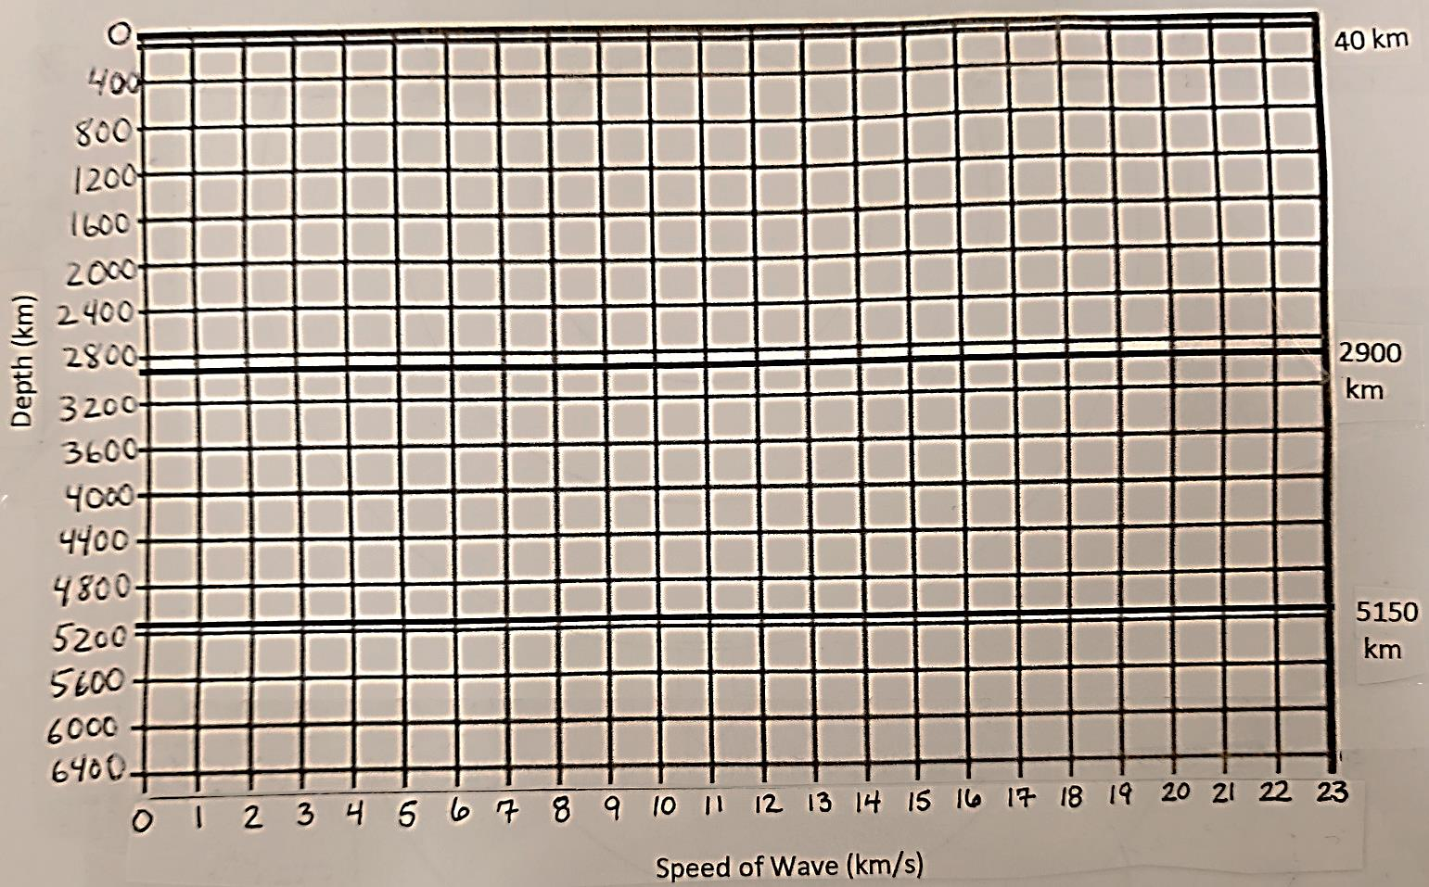
Graph Interpretation: Describe the relationship between the layers of the Earth and the speed of the S and P waves. ____________________________________________________________________________________________________________________________________________________________________________________________________________________________________________________________________________________________________________________________________________________________________________________________

