Igneous Rocks
What are they made of?

How are they formed?

What are the two types of Igneous Rocks?

Compare and Contrast the two types of Igneous Rocks
What elements are light colored rocks composed of?

What elements are dark colored rocks composed of?

Describe viscosity:

Compare and Contrast Magma that has low and high viscosity

Why does adding water to magma make it more explosive?

Sedimentary Rocks
What are they made of?

How are they formed?

What are the three types of Sedimentary Rocks?

What are they made out of?  How did they form? | What are they made out of?  How did they form? | What are they made out of?  How did they form?

Compare and Contrast Weathering and Erosion
Define chemical weathering:

Define /mechanical physical weathering:

Define the processes of how sedimentary rocks are formed:
Uplift-

Weathering-

Erosion-

Deposition-

Burial-

Lithification-

Compaction-

Cementation-

Metamorphic Rocks
What are they made of?

How are they formed?

What are the two types of Metamorphic Rocks?

Compare and Contrast the two types of Metamorphic Rocks

Rock Cycle
Fill in the blank rock cycle. Make sure to label the arrows.
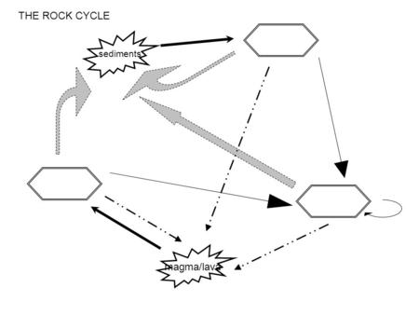
- Heat and pressure may change a rock to a metamorphic rock.
  - Using the diagram above, what type of rock may be changed into a new metamorphic rock? __________________________________________
- Melting followed by crystallization will change a rock to an igneous rock.
  - Using the diagram above, what type of rock may be changed into a new igneous rock? __________________________________________
- Uplift, weathering, erosion, deposition, burial and lithification will form a sedimentary rock.
  - Using the diagram above, what type of rock may be changed into a new sedimentary rock? __________________________________________

