Things to Do to Guarantee Success on the Rocks’ Test
5-day Calendar
 | Sunday | Monday | Tuesday | Wednesday | Thursday
In Class | No Class.  In Class on Monday we will be doing Finish Classifying Rocks Activity & Discuss  Work on Sedimentary & Metamorphic Rocks Packet  . | Finish Classifying Rocks Activity & Discuss  Work on Sedimentary & Metamorphic Rocks Packet | Rock Cycle Crayon Lab | Finish Rock Cycle Crayon Lab  Rock Cycle Notes  PYP Formative Assessment  Review Packet  8th Hour Study Session | Morning Study Session  Review Day  Igneous Rocks Station  Sedimentary Rocks Station  Metamorphic Rocks Station  Rock Cycle Station  Review Packet Station  Rapid Fire  Quizlet Live/Kahoot  8th hour Study Session
Out of Class | Study Vocab  Work on Review Packet. | Study Magma and Igneous Rocks  Understand Magma viscosity and how it forms different types of igneous rocks.  How does viscosity influence explosiveness?  (Slides 7-16 and slide 52 in PowerPoint)  Work on Review Packet. | Study Sedimentary Rocks and 6 Processes of Formation  Sediments and Sedimentary Rocks  Weathering vs. Erosion  6 processes of Formation  (Slides 17-37 and slides 46 and 47 in PowerPoint)  Work on Review Packet  . | Study Metamorphic Rocks and Rock Cycle  Foliated vs. Non-foliated  Formation and Composition of Metamorphic Rocks  Rock Cycle  (Slides 38-44 and slides 50 and 51 in PowerPoint)  Work on Review Packet | Test Topics:  Igneous, Sedimentary, Metamorphic Rocks  Rock Cycle  Rock Identification  Friday Morning:  Wake up on time.  Eat a well-balanced breakfast.

Name:

End of the Chapter Checklist

- Are your notes completely filled out?

Yes (Go on to the next step)

No (Get notes from another student or online)

- Do you have any missing work? (Check Board and/or IC)

Yes (Come in 8th hour or before school to make it up)

No (Go on to the next step)

- Have you missed any points on a lab?

Yes (Come in 8th hour or before school to ask questions and fix your mistakes)

No (Go on to the next step)

- Have you scores perfects on all your Formative Assessments?

Yes (Go on to the next step)

No (Come in 8th hour or before school to get help and fix mistakes)

- Did you fill out your review guide?

Yes (Go on to the next step)

No (Complete this ASAP)

6. Did you check your review guide for accuracy?

Yes (Now, just study and you will be ready!)

No (Come in 8th hour or before school to check your work)

Chap 5 & 6 Review Study Guide Name________________________Period______

IGNEOUS ROCKS:
- How do all igneous rocks form?

- If you look at a rock, what observations might indicate it is an igneous rock? (See last page of notes.)

- What is the difference between magma and lava?

- Fill in the Table below Regarding Extrusive and intrusive Rocks:

 | Where do these rocks form? | What do the rocks look like? (Describe Crystal Size) | Fine Grained or Coarse Grained
Extrusive
Intrusive

- What affects the color of an igneous rock?

- What is viscosity?

- Fill in the table below regarding igneous rocks and the magma they form from.
Types of Magma | Elements found in the magma. | Viscosity of the magma | Rock Color | Type of Volcanic Hazard Produced
1). Rhyolitic

2). Basaltic

- When you add water to magma:
  - What happens to the viscosity of the magma?

  - What happens to the melting point of the magma?

  - What happens to the explosiveness of the volcano?

- What must happen to a sedimentary rock covered in fossils to produce an igneous rock?

- Describe the following special igneous rocks. What do they look like? Intrusive/extrusive?
- Obsidian

- Pumice

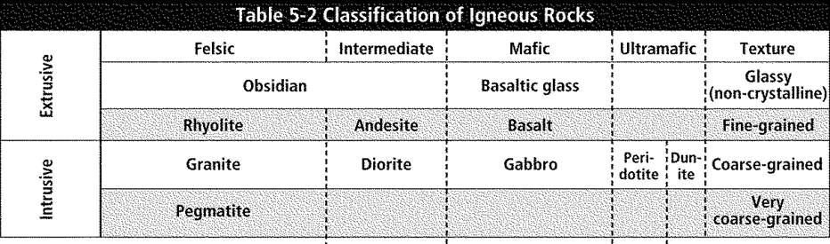
Light-Colored
Medium Color
Dark-Colored
Really Dark

- Using the diagram above, describe the following about Rhyolite:

  - Color:

  - Texture:

  - Location where it formed:

- List and Define two processes that must be present to form an igneous rock?
1.

2.

Sedimentary Rocks

- What is a “sediment”?

- If you look at a rock, what observations might indicate it is a sedimentary rock? (See last page of notes.)

- What are the 3 subtypes of sedimentary rocks?
**For each type, tell how the subtype forms.

c.

- Describe the 2 types of weathering that can occur in nature and provide an example of each.
**Make sure you are able to explain what your example is and how it works.
  - Physical/Mechanical

  - Chemical

- How is weathering different from erosion?

- Define deposition:

- Lithification:
  - Define lithification:

  - How do you know when lithification has occurred?

  - List and describe the two steps that occur as a part of lithification.

- What would need to happen to obsidian to turn it into sediments?

- After the obsidian turns to sediments, what must happen to them to produce a sedimentary rock?
  - Include the following words in your description: Erosion, Deposition, Burial, Compaction, Cementation, and Lithification.

Metamorphic Rocks
- If you look at a rock, what observations might indicate it is a metamorphic rock? (See last page of notes.)

- Fill in the table below regarding Metamorphic Rocks.
Types of Metamorphic Rocks | How was the rock formed? | Describe and/or draw the appearance of the rock.
1.

2.

Rocks Cycle:
**NOTE: There will NOT be a rock cycle diagram on the test. **You must be able to list AND EXPLAIN all the processes/steps involved in making each type of rock. **That means at least 2 steps for forming igneous rocks, at least 2 processes to form metamorphic rocks, and 7 processes for sedimentary rock formation.

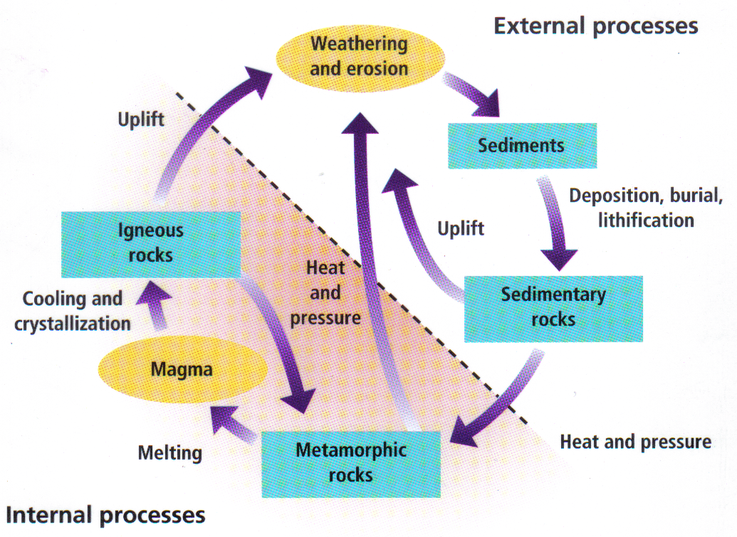

- In the diagram above, write the names of the processes/steps that the arrow represents. NOTE: Some boxes will have more than 1 process in them.
- Marble is a metamorphic rock. Using the diagram on the previous page, list ALL the processes marble must go through to become:
  - An igneous rock

  - A new metamorphic rock

  - A sedimentary rock

- What types of rocks can turn into sedimentary rocks?

To Help You Identify Rocks on the Test
Several of the rocks from the Classifying of Rocks Lab will be on the test. Be sure you can identify the following for each rock.
 | Igneous |  | Sedimentary | Metamorphic
List TWO UNIQUE VISIBLE features that will help you recognize these different rock types. | 1.  2. |  | 1.  2. | 1.  2.
Fill in the boxes to the right by listing sub-groups for each rock type and how to recognize it. | Color | Color | Method of formation | Method of formation
 | Color | Color | Method of formation | Method of formation
 | Crystal Size | Crystal Size | Method of formation | Method of formation
 | Crystal Size | Crystal Size | Method of formation | Method of formation

