Name__________________________Period ____

NOTE OUTLINE: Chapter 21 Fossils & the Rock Record
Objectives:

- The Geologic Time Scale
- I understand how Earth’s history is divided into sections of time called the geologic time scale. This means I can:
  - Explain how major changes mark the boundaries between the sections.
  - Discuss the general changes in organisms from the appearance of life on Earth to present day.

- Fossils
- I can describe the characteristics of Index Fossils and explain how Index Fossils are used.
- Discuss how fossils can be used to interpret Earth’s past physical and environmental history.

- Dating of Rocks
- I can apply the principles for determining relative age to interpret rock sequences. This means I can:
  - Determine the oldest and youngest layers using the Law of Superposition.
  - Determine the relative age of layers and intrusions.
  - Match rock layers in different areas using Correlation.
- I can apply the principles for determining absolute age using radioactive decay rates and half-lifes.
- I can discuss the differences in the radioactive decay of different elements. This means…
  - I can describe when to use Carbon-14 vs Uranium-238.
  - I can describe limitations of Carbon-14 and Uranium-238 when dating objects.

TWO Types of Dating of Rocks

- Absolute Dating determines the _______________________________ age in ______________

- Relative Dating simply classifies rocks or fossils as ____________or __________

ABSOLUTE - Age Dating of Rocks

Review: Absolute Dating determines the ________________________________ age in _________

Radioactive decay of elements is used to determine the absolute age of rocks

- Radioactive elements ______________ into a _________element

  - Example: _____________ changes into __________________

Half-Life

- The half-life of an element is the _______________________________ of the atoms in the element to

decay into a new element.

- By measuring the percent of parent isotope left, absolute age can be determined.

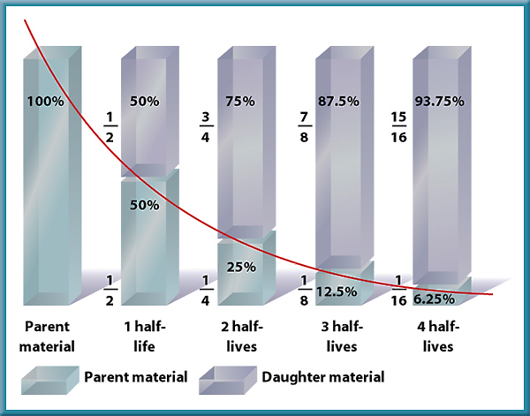

Your Turn: Half-Life Determination from Graph
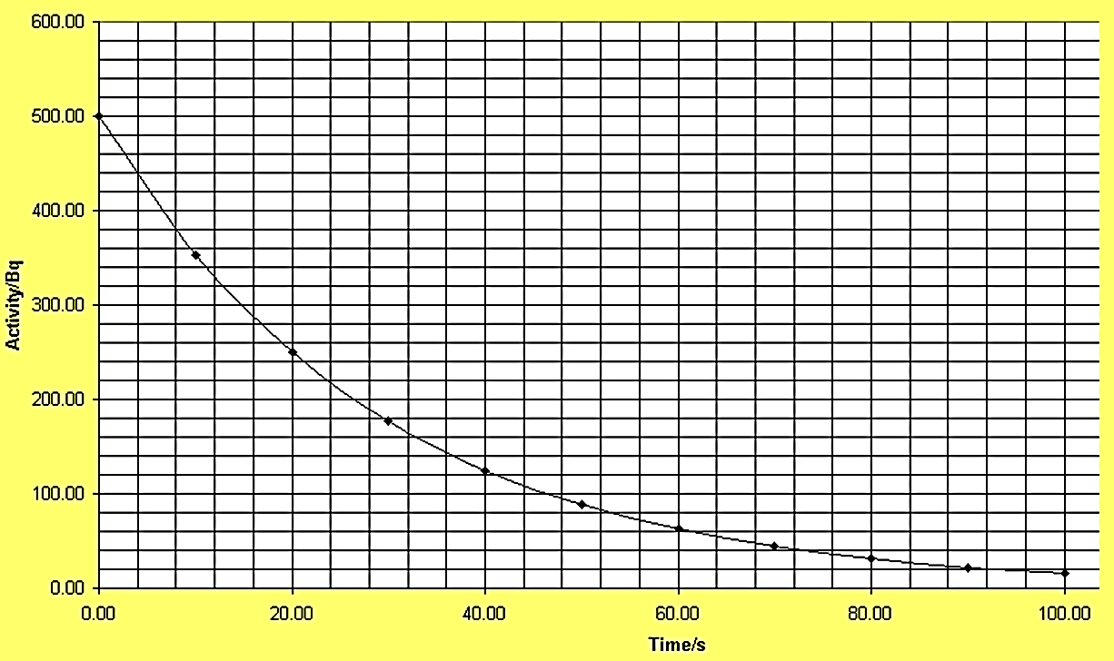
What is the half-life in this graph?

Review of Computer Simulations: What Radioactive Elements can be used for Dating?

 | Carbon - 14 | Uranium
What is it’s half-life?
What objects can it date?
What are it’s limitations? (When can it NOT be used?)

Carbon Dating

- C-14 is used to date ________________________ remains

- During life, animal __________________________ and __________________ in foods

- After death, ___________________________ is taken in.

- Age of a fossil is calculated by how much C-14 is left.

- Older fossils have:
  - Less C-14
  - More Nitrogen (What C-14 turns into)

- Can only be used on fossils __________________________________________ years old

Other Radioactive Elements

- Other elements used to date rocks include:

  - Uranium-238 (U-238)

- Half-life = ________________ Years

- Used on _____________________________ years old

- Uranium changes to ___________

  - Uranium-235 (U-235) Half-life = 0.7 Billion Years
  - Potassium-40 (K-40) Half-life = 1.25 Billion Years

 | Percentage  Uranium -238 | Percentage  Lead | Age  (billions of years)
Beginning Amount
After one half-life
After two half-lives
After three half-lives
After four half-lives

RELATIVE - Age Dating of Rocks

Ways to Determine Relative Age

- Law of Superposition can be used in rock that is ________________ (moved around by tectonic forces)

  - Older rocks on ______________.

  - Younger rocks on ____.

- Uniformitarianism: Theory that states the ______________happening on Earth _________ have been

occurring since Earth ____________________

- 2 types of processes:

- _____________everyday processes

  - take thousands of years to change the land

  - _____________________________________

- _________________________________ events

  - change the land instantly:

  - ______________________________________________

- Exceptions to Law of Superposition

- Earthquakes, faults, volcanism, flooding, weathering & erosion:

  - _______________the rock layers

  - Make it _________________ to use the Law of Superposition

- Intrusion: _____________that flows _____________ of existing rocks and cools into igneous rock

  - Intrusions are always ____________________than the layers they pass through

- Distinctive Sediment Layers

  - Correlation is matching rock layers from one location to another by matching_____________

______________________________________________. Examples:

- Sandstone containing oil, ammonite fossils
- Grand Canyon (Arizona), Zion (Utah), Bryce (Utah)

  - _________________ events such as ___________ impact or massive ____________________

form DISTINCTIVE layers used to determine relative age.

Examples:

    - Mount St. Helen’s 1980 – _______over several states makes a layer known to have

been made in_____________

    - _______________ impact at the boundary of the ______________and

_______________ time periods left a layer of space material.

      - Layer is age of the __________________ extinction

Section 21.1 Geologic Time
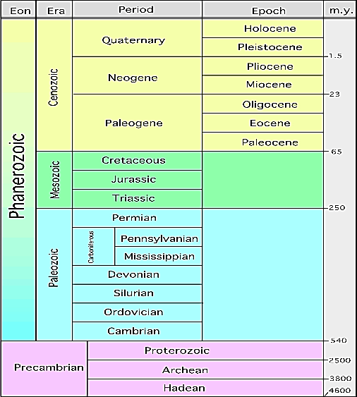
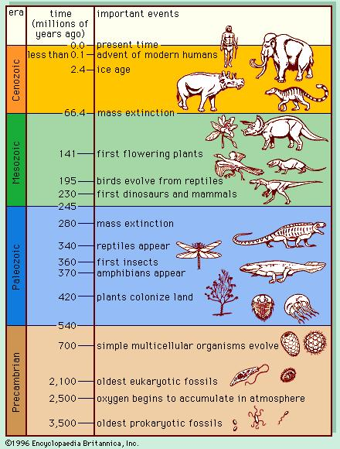

Measuring Time:

- According to current theories, the Earth has existed for _______________ years

What Units of Time are Used to Measure Earth’s History??

The 4 Main Units:

- Eon: ______________ amount of time
- Era
- Period
- Epoch: ______________ amount of time

How Are They Listed?

- Recent at ___________

- Oldest listed at ____________________

Precambrian Time

- Began with the ___________________of the Earth (______________ years ago)

- At first, there was ___________________________________

- The first organisms appeared in the ____________________ , _____ billion years ago

  - They were single-celled _______________

Cambrian Explosion – Beginning of Paleozoic Era

- The _________________________________ marks the boundary between Precambrian Time & Paleozoic Era.

  - _________________________________________ life forms appeared

  - Organisms had ________________ parts (shells, exoskeletons) which left many more fossils

Beginning of Mesozoic Era

- Many _________________became _________ at the boundary between Paleozoic & Mesozoic Eras.

- _________________________ appear

- Mesozoic Era is known as the “Age of _____________”

End of Mesozoic Era

- All __________________ and many animals & plants went _______________

- Theory:

  - Scientists think an ______________ hit Earth

  - Dust clouds blocked the _______________, causing ________________to die, then herbivores, then carnivores.

Cenozoic Era

- Current era – the one we are living in

- AKA: Age of ___________.

- __________________ appear.

- We know the ______________ about this Era because the fossils are in the _______ layers and are easier to find

Why Do We Switch Eras?
Class Discussion: What are the Actual Reasons There Are Era Switches?

YOUR IDEAS: Using the information on pages 4-6 of your notes, work with your group and create an inference on how time is divided. Record your thoughts in this box.

How Are Smaller Periods & Epochs Divided?
Smaller divisions of time (Periods & Epochs) are based on changes in life forms AND land formation changes. Examples:

  - North America is covered by _________________________

  - ______________________breaks up

  - _____________________________ form

  - Grand Canyon forms

Remains of Organisms in Rock Record

- Fossil = ___________________________________________of a once-living plant or animal

- Fossils help scientists approximate:
  - When life began
  - Types of animals and plants
  - Extinction of species

- Most organisms ___________ and don’t become fossils

- Fossils are more likely to form if:

  - Quick _______________occurs

    - Protects the fossil from being eaten by predators

    - Prevents it from being ___________________

  - Organism has ______________ body parts (bones, teeth, shells)
Index Fossils

- Index Fossils = Fossils used to ___________ rock layers or to ____________________ of a rock layer.

- Characteristics needed to be an Index Fossil:

  - Easily__________________

  - _______________________________

  - Lived during a _____________ time

- Examples: Trilobites, dinosaurs

Trace Fossils

- Trace Fossils = INDIRECT evidence of the _____________________ of life.

- Examples include:

  - Fossilized ___________________

  - __________________________

  - Fossilized ______________ (coprolites) – can help scientists learn about eating habits of ancient animals
Half-Life Problem #1
- We start with 40 grams of Ra-226
- Ra-226 has a half-life of 1620 years
- How much is left after 8100 years?
# of half-lifes | % Ra-226 Remaining | Time (Years) | Amount (grams) Ra-226 Left
0
1
2
3
4
5
Half-Life Problem #2
- A sample of Iodine-131 had an original mass of 16g
- How much will remain in 24 days if the half-life is 8 days?
# of half-lifes | # Days | Grams of I-131 remaining
0
1
2
3
4

