MONDAY
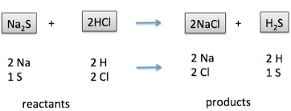
Do they elements change?______________
Is this a chemical/physical reaction? _______________

TUESDAY
- 65.4cg _____________mg
- Boyle’s law says that if temperature increases that pressure will ___________
- When paper is set on fire what kind of reaction is taking place __________________

WEDNESDAY
- 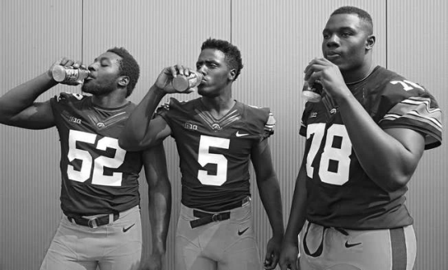 create a hypothesis about this picture.

- Write the phase change Condensation _______ to ________

THURSDAY
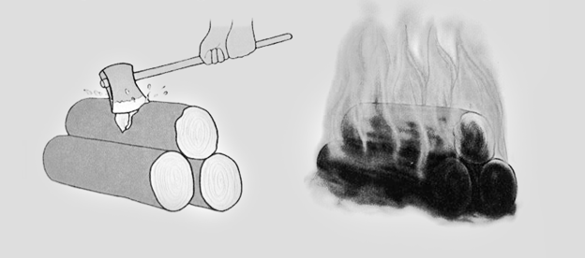
- Identify which is a chemical change / physical change and explain why for each.

- Write the phase change for melting ___________ to _____________

FRIDAY
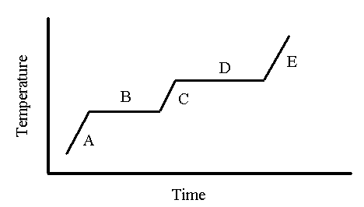
- What does B represent on this graph? ________________________
- What does E represent on the graph? _________________________
- If a log is floating does it have more/less density than water? ____________ explain

