MONDAY

1. Mass = 73.5g volume = 55mL calculate density.
2. 13.3g/mL b. 1.33g/mL c. 133g/mL
3. 56.3568Kg to ____________G
4. 5635.68 b. 5.63568 c. 56356.8
5. If pressure increases what happens to volume?
6. Increase b. decrease c. nothing

TUESDAY

  

  

1. label boxes with air / solid
2. Which molecules move the fastest? A. air B. water C. solid
3. Density = 3.45g/cm3 volume = 54cm3 what is the mass?
4. 18.63g b. 1863g c. 186.3g

WEDNESDAY

1. 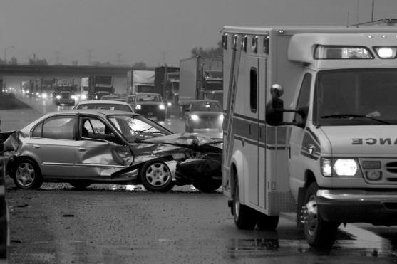 write a hypothesis about this picture
2. 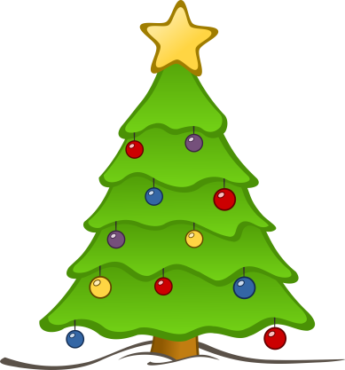 put the bulbs in even groups. _________________

THURSDAY

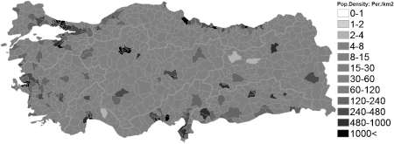

1. If you were hunting for turkeys circle a place on the map that you would want to go to find them.
2. 743.432M to __________________Dm
3. 7434.32Dm b. 7.43432Dm c. 74.3432Dm
4. A rock’s mass is 74.8g. You fill a graduated cylinder to 50mL. After you put the rock in the graduated cylinder reads 57.8mL. What is the density of this rock?
5. 9.59g/mL b. 95.9g/mL c. 0.959g/mL

FRIDAY

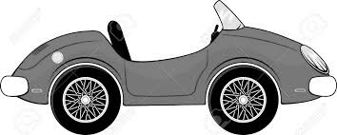

1. List 3 physical properties of this car and 1 physical change.
2. The density of this car is 7843g/mL, the mass is 4578kg what is the volume?